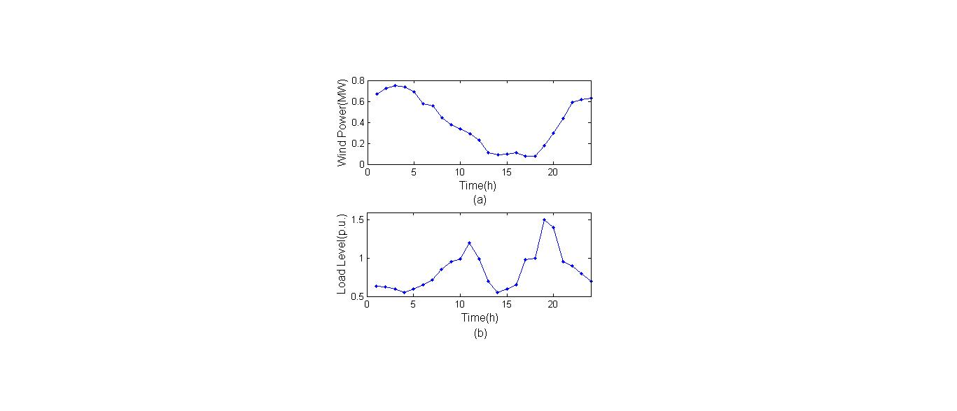

1. Wind Turbine output curve (b) Load curve

Other parameters:

|  |  |  |  |
| --- | --- | --- | --- |
|  | 0.1MW |  | 0.24$/time |
|  | 0.5MW |  | 0.24$/time |
|  | 0.2MW |  | 298K |
|  | 1MW |  | 298K |
|  | 1MVar |  | 5Mpa |
|  | 1.2MVA |  | 3Mpa |
|  | 286.7 |  | 7Mpa |
|  | 2000m^3 |  | 5.4*10^7 |
|  | 8 |  | 1.08*10^7 |
|  | 8 |  | 9*10^7 |
|  | 8 |  | 90% |
|  | 40$/MWh |  | 0.95^2 |
|  | 1.4$/time |  | 1.05^2 |